**Experiment 1.3**

**Name :- Yash Gupta UID :- 20BCS45009**

**Course :- CSE Class :- 706-B**

**Subject Code :- 20CSP-255 Subject :- Software Engineering Lab**

# AIM:

**Question 1 :-**

Draw a level 0 Data Flow Diagram (DFD) that fits the following system:

Students login with an email Id and password and the system provides access to the schedule for the current quarter. Students pick classes and enrol in them. Enrolments are recorded in rosters. The system formats rosters for each class and sends them to teachers. Teachers can drop students on their rosters.

The DFD should have more than one process, more than one source/sink and more than one data store. The words in bold in the above box should appear in your diagram at least once. You may have to invent some names.

**Question 2 :-**

Draw a level 1 DFD for the following scenario

The software proposed is Food Ordering System. It has participants who will interact with the system, called the external entities. The Supplier, Kitchen, Manager, and Customer are the entities who will interact with the system. In between the process and the external entities, there is data flow (connectors) that indicate the existence of information exchange between the entities and the system.

# Requirement Analysis:

Software Requirement:

* Lucid Chart
* Google Chrome

# DATA FLOW DIAGRAM(DFD) :

Data flow diagram is graphical representation of flow of data in an information system. The DFD does not mention anything about how data flows through the system. It is capable of depicting incoming data flow, outgoing data flow and stored data.

Question 1:-

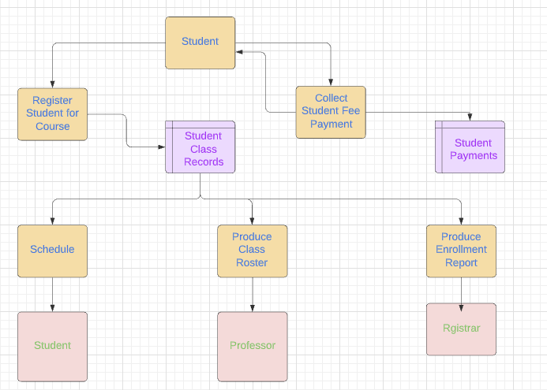

Question 2:-

